MOUNTAINS OF THE MOON UNIVERSITY
FACULTY OF SCIENCE, INNOVATION AND TECHNOLOGY.
DEPARTMENT OF COMPUTER SCIENCE.
FUNDAMENTALS OF WEBSITE DEVELOPMENT
INDIVIDUAL ASIGNMEMT.

STUDENT’S NAME: AINEMBABAZI SHEILLAH
REG NUMBER: 2023/U/MMU/BIT/00844
COURSE CODE: BIT 1204
YEAR: ONE
SEMESTER: TWO
LECTURER’S NAME: MR. MWANJE DERRECK
DATE OF SUBMISSION 22/01/2024

QUESTIONS
As a Web site Developer student, critically analyze at least six different websites for the
following categories;
✓ ECommerce
✓ Universities
✓ Hospitals
✓ URA
✓ Government Ministries
✓ NGOs
✓ IT Companies
Required:
1. Document the domain for each of the above selected websites.
2. Capture screen shots of the home pages containing the main Menu for each of the selected entity or category above.
3. Evaluate, critique and document the color choices for each of the selected websites.
4. Document the similar controls and components cutting across the above websites.
5. Generally, Critique the above selected websites, citing the loopholes, setbacks.
6. Identify and document the visible security features from the above websites
7. Basing on the critiques report, in your opinion Suggest ways in which the above websites could be improved.

Answers
- (a) Website domains
Ecommerce: kikuu.com
Universities: kyu.ac.ug
Hospitals: mbararahospital.go.ug
Government Ministries: defense.go.ug
URA: ura.go.ug
IT company: ibm.com

- kikuu.com
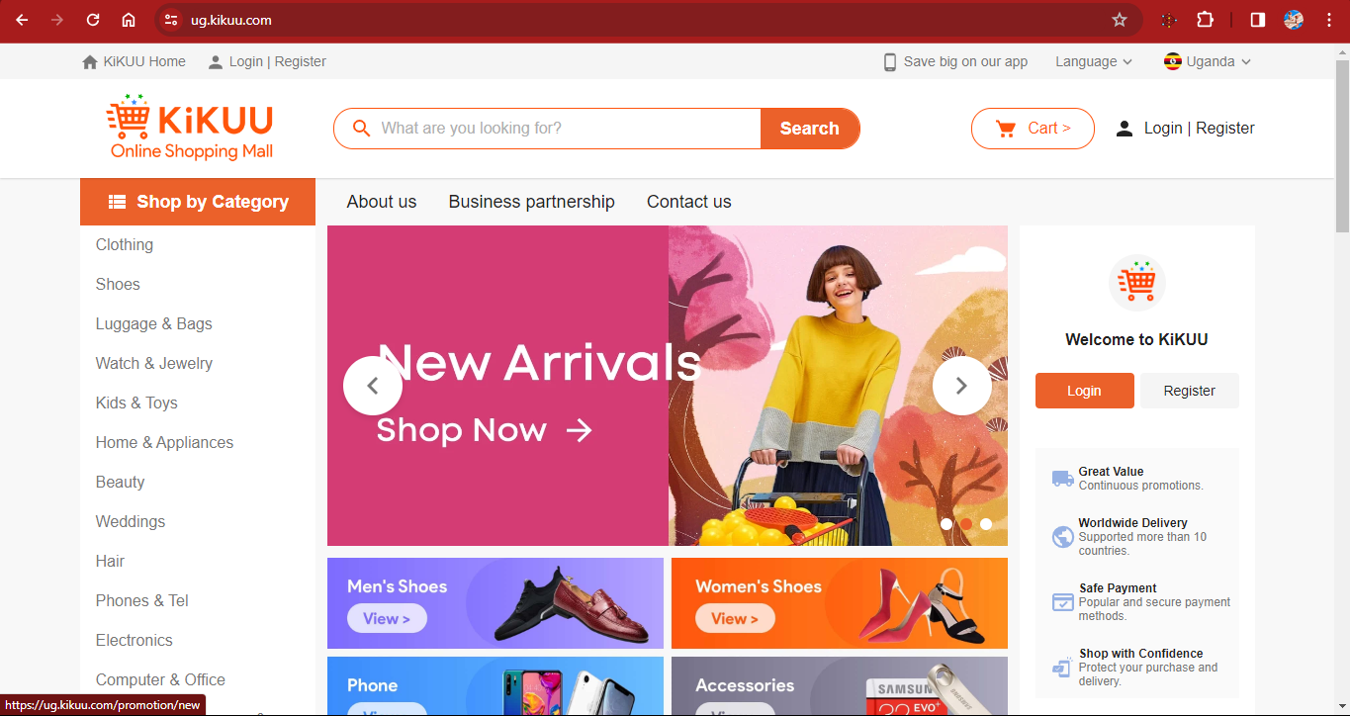

Kyambogo university
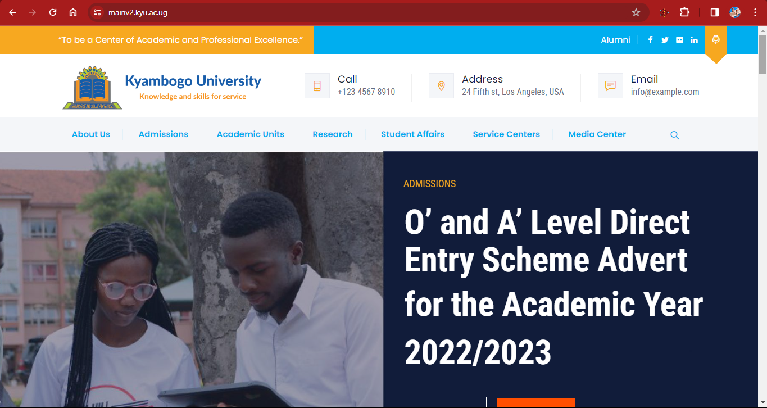

Mbarara hospital
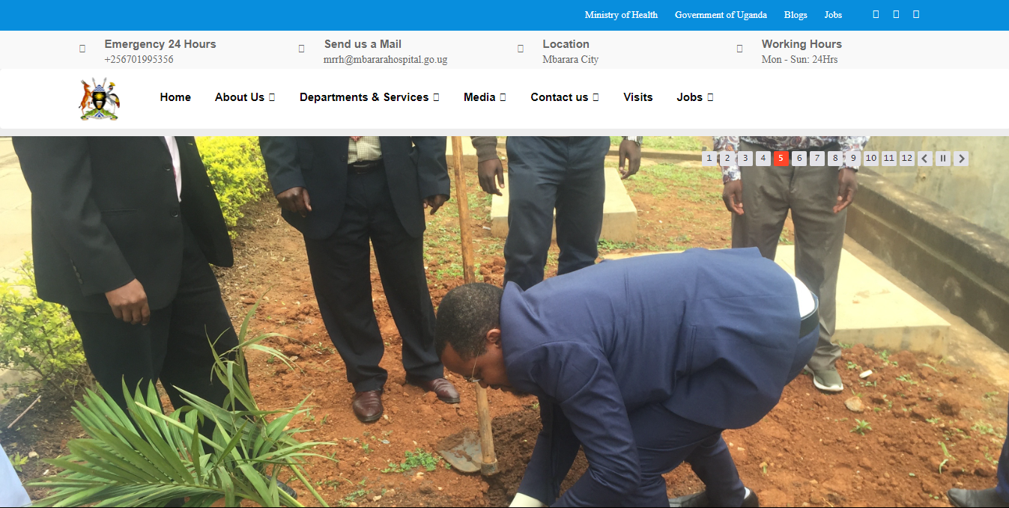

IBM


URA
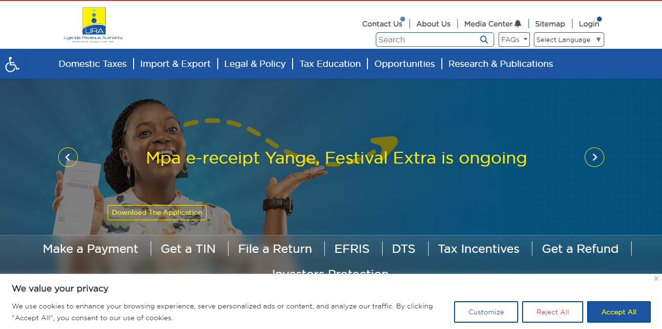

Ministry of defense
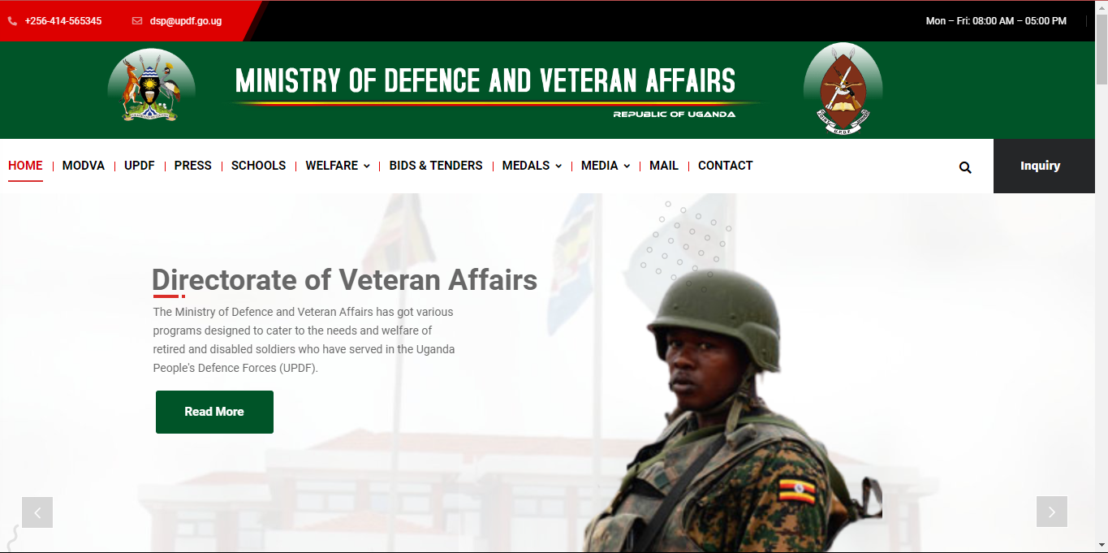

- Documentation of color choices
- Kikuu.com
- The color choices of kikuu.com make their products more visible to the customers. For example, colors like orange which attracts the attention of anyone who visits the website.
- Color white is bright which enables the visual image of other words on the website.

- Kyambogo university
- The color white appears bright on navy blue.
- The color also makes the words easily readable by the students and those who visit the website.

- Mbarara Hospital
- They used light and attracting colors

- Uganda Revenue Authority
- The blue color in the background on the home page matches with the URA logo
- The yellow color in the picture also matches with the colors on the logo of URA
- The themes are transparent making the content of the website both readable and visible to whoever visits the website

- IBM
- The website uses color white which brings out the information clearly.

- Ministry of defense
- There is use of army green which reflects the soldier’s uniform
- The use color red indicates brotherhood.

- components and controls
Buttons
Links
Footers
Search areas

- Loopholes and setbacks
- The kikuu website is too congested with a lot of content on a single page .
- The URA website lacks detailed information.
- The website of Mulago hospital lacks information which makes the people who visit the website get limited information.
- The IBM website has bright colors which may not favor people with eye defects.
- The ministry of defense website is so brief.
- The Kyambogo university website lacks detailed information yet it is an education organization.

- Visible security features
- Secure payment methods
- Kikuu uses secure payment method for example mobile money.
- URA also uses secure payment method like the use of bank transfer.
- Privacy Policy
- All the websites use access control since they deal with various user accounts.

- In my opinion, the following are the ways in which the websites could be improved
- Through content and information up-to-date for accuracy and relevance.
- Through making sure that all information on the website is accessible.
- Through providing feedback in time.

